
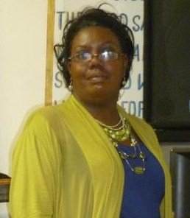
Divas For Christ 1st Annual Fall Tea
{New Way Covenant MBC}
2837 NW 6th Street…Pompano Bch

August 17, 2013 @ 10 am…Tickets $20.00
Note: (Each Diva Member is an individual participant)



Hostess, !st Lady Annette Moore

To purchase tickets, you may contact any Diva member…go to our website on the
DIVAS page @ www.newwaycovenantmbc.yolasite.com and put in your request
for your tickets with any Diva that you want to sponsor. Each participating Diva has a
table and whoever you sponsor, that’s the table that you will sit.

Theme:
“Life In Transition” Shedding Off The Old Identity

Diva Officers
Elect Lady Annette Moore, President (954-825-3014)
Sonya Bryant, Director (954-204-7425)
Irma Walker, Financial Secretary
Val Mosbey, Secretary
Jazmine Morris, Financial Director


